Emotion Recognition System



SUBMITTED BY
UNEEB ALI 70136545
NASHIT BUTT 70134828
HUSSAIN 70134549
ATTEED AHMED 70135351
EMAN AWAIS 70135826

THE UNIVERSITY OF LAHORE
------------------------------------------------------------

Table of Contents
🎭 Emotion Recognition System: Technical Documentation 3
1. Introduction 3
2. Problem Statement 3
3. The Solution 3
4. Objectives 3
6. Methodology & Model Architecture 4
6.1 Data Preprocessing 4
6.2 Training Pipeline 4
7. Project Structure 5
8. Experimental Results 5
9. Implementation Guide 5
Installation 5
Usage 6
10. Conclusion & Future Work 6
USER MAUAL 7
RESULTS 8

🎭 Emotion Recognition System: Technical Documentation

1. Introduction
In the era of digital transformation, understanding human sentiment through text has become vital for businesses and social science alike. Emotion Recognition goes beyond simple "Positive" or "Negative" sentiment analysis by identifying specific affective states such as Joy, Sadness, Anger, and Surprise. This project presents a full-stack AI solution that leverages Natural Language Processing (NLP) and Machine Learning to interpret human emotions from textual data in real-time.

2. Problem Statement
Human language is inherently complex, filled with nuances, slang, and varying emotional undertones. Traditional rule-based systems often fail to capture the context of words, leading to inaccurate sentiment detection. Furthermore, many existing models are computationally heavy, making them difficult to deploy in real-time environments. There is a need for a lightweight, highly accurate, and scalable system that can process both individual inputs and batch data instantly.

3. The Solution
This project provides a robust, end-to-end pipeline to solve the emotion detection challenge:
- Engine: A Machine Learning model trained on 20,000+ labeled samples using a optimized Logistic Regression classifier.
- Vectorization: Utilizing TF-IDF (Term Frequency-Inverse Document Frequency) to convert text into meaningful numerical patterns.
- Interface: A modern, responsive Flask web application that allows users to interact with the model via a UI or a REST API.
- Efficiency: Achieving a high accuracy of ~89% while maintaining low latency for real-time predictions.

4. Objectives
- Automate the classification of text into six core emotions: Joy, Sadness, Anger, Fear, Love, and Surprise.
- Develop a RESTful API for seamless integration with third-party applications.
- Provide visual feedback through probability distributions, allowing users to see the "confidence" of the AI.
- Implement a clean, professional UI for non-technical users.

5.TechStack
Category | Tools/Technologies
Language | Python 3.x
ML Libraries | Scikit-learn, NLTK, Pandas, NumPy
Backend | Flask (Python Web Framework)
Frontend | HTML5, CSS3, JavaScript (Fetch API)
NLP Techniques | Lemmatization, Stopword Removal, TF-IDF Vectorization
Deployment | Gunicorn, Heroku/Render

6. Methodology & Model Architecture

6.1 Data Preprocessing
Before training, the raw text undergoes a rigorous cleaning process:
- Regex Cleaning: Removing special characters, URLs, and mentions.
- Tokenization: Breaking sentences into individual words.
- Stopword Removal: Eliminating common words (the, is, at) that carry no emotional weight.
- Lemmatization: Reducing words to their root form (e.g., "running" to "run") using WordNet.

6.2 Training Pipeline
The model uses a Logistic Regression classifier. While simpler than deep learning, it provides excellent performance for text classification tasks when paired with a high-quality TF-IDF vectorizer, ensuring the system remains lightweight and fast.

7. Project Structure
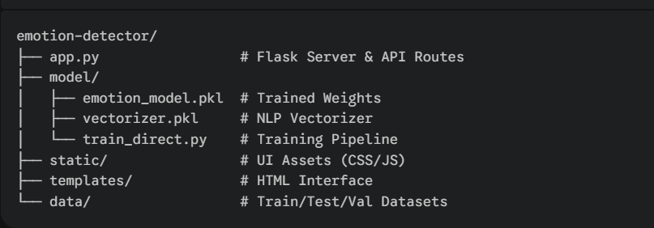

8. Experimental Results
The model was evaluated using a split-validation strategy:
- Training Samples: 16,000 images
- Validation/Test: 4,000 images
- Overall Accuracy: 88.7%
- Performance Metrics: The model shows particularly high precision in detecting "Joy" and "Sadness" due to distinct vocabulary patterns in the dataset.

9. Implementation Guide

Installation

git clone https://github.com/70136545-UNEEB/emotion-detector-.git
cd emotion-detector-
python -m venv env
source env/bin/activate # or env\Scripts\activate on Windows
pip install -r requirements.txt

Usage
- Run App: python app.py
- Access UI: http://127.0.0.1:5000
- API Call:
curl -X POST -H "Content-Type: application/json" -d "{\"text\": \"I am so happy today!\"}" http://127.0.0.1:5000/predict

10. Conclusion & Future Work
This system successfully demonstrates how Machine Learning can be applied to human-centric data to provide meaningful insights. Future Enhancements:
- Deep Learning: Transitioning to BERT or Transformers for even higher contextual accuracy.
- Multilingual Support: Expanding the model to detect emotions in Urdu, Spanish, or French.
- Deployment: Containerization using Docker for enterprise-scale deployment.

USER MAUAL
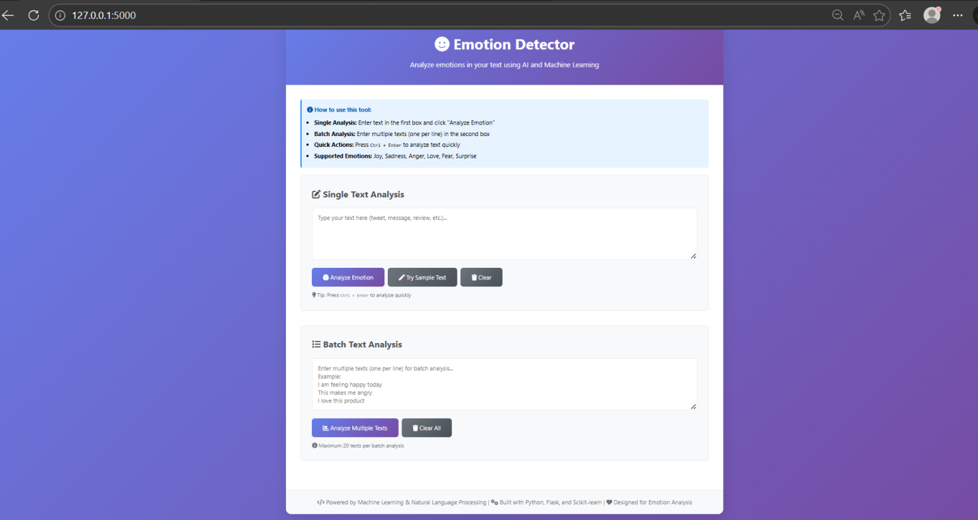

RESULTS

